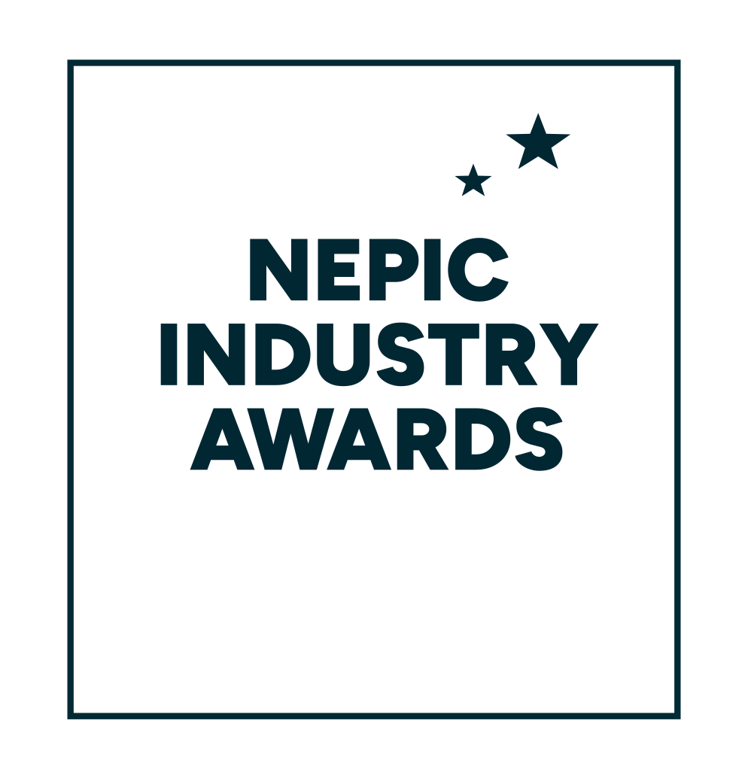

**28 March 2025**

**Hardwick Hall Hotel**

**YOUNG ACHIEVER AWARDS**

Entry form and award criteria

**ABOUT THE YOUNG ACHIEVER AWARDS**Representing the largest business sector in the North East of England, NEPIC has deep engagement with industry and training providers which enabled the North East to be a prime mover in the development of plans and establishment of a Process Industry National Skills Academy.   
  
But NEPIC seeks not only to promote the industry as a career choice for those leaving school and university, but also to recognise the ­­­­­­­­­young people already working within it.  
  
To recognise and celebrate the region’s young talent from within the process sector, NEPIC are pleased to once more welcome entries for the 2025 Young Achiever Awards. As always, we recognise talent across industry, with applicants welcome from the following sectors:  
  
**Biotechnology  
Pharmaceuticals  
Fine & Speciality Chemicals  
Commodity & Petrochemicals  
Support & Supply Chain**As well as receiving a trophy to mark the winner’s success at the prestigious NEPIC Annual Awards Dinner, held at Hardwick Hall on the evening of Friday 28 March 2025, each of the five award winners will receive a prize of £1,000.  
  
**“IT’S A GREAT TIME TO BE ON TEESSIDE, WE’VE GOT A REALLY GREAT TALENT POOL AND I HOPE WE CONTINUE TO DEVELOP PEOPLE”.**Emma Robinson of Sembcorp Energy UK, previous Young Achiever award winner

**How to enter:**  
  
Please complete the entry form below in full, ensuring you answer each of the 5 criteria.  
  
**Please note that applicants should be under the age of 35 as of 31 December 2024**.

Completed forms should be submitted electronically, clearly stating your name and chosen category on the top of the document, no later than the entry deadline of  
**31 December 2024** to [awards@nepic.co.uk](mailto:awards@nepic.co.uk).

**We wish you the very best of luck with your entry!**

**THE YOUNG ACHIEVER AWARDS  
Entry form  
  
Part 1: Personal details**

**Please complete the following entry form and return electronically along with a recent photograph. As part of the award process we ask that a senior manager from within your organisation supports your application - please ensure that this section is also completed.**

|  |  |  |
| --- | --- | --- |
|  | | |
| **Please indicate which**  **sector your application  is representing.** *Please tick (✓) only one:* |  |
| Biotechnology |  |
| Pharmaceuticals |  |
| Fine & Speciality |  |
| Commodity & Petrochem |  |
| Support & Supply Chain |  |

|  |  |
| --- | --- |
| **Your Details** |  |
| Name |  |
| Job Title |  |
| Company |  |
| Company Address |  |
| Postcode |  |
| Telephone No. |  |
| Mobile No. |  |
| E-mail Address |  |
| Date of Birth |  |
| **Managers/Sponsors Details** |  |
| Name |  |
| Job Title |  |
| Telephone No. |  |
| E-mail Address |  |

**THE YOUNG ACHIEVER AWARDS  
Entry form**

**Part 2: Award Criteria**

**Please provide a supporting statement for each of the 5 criteria.**

|  |
| --- |
| 1. How did you begin your career within the industry and how did that evolve over the first few years? |
| Type answer… |

|  |
| --- |
| 1. What has been your main achievement within your current role? |
| Type answer… |

|  |
| --- |
| 1. Describe a specific project you have worked on that has contributed to the improvement of your company efficiency or field of work. |
| Type answer… |

|  |
| --- |
| 1. How have you continued to develop your skills and knowledge?  *This could include involvement in industry groups and associations*. |
| Type answer… |

|  |
| --- |
| 1. What are your career goals for the next 3-5 years and how do you plan to contribute further to the industry? |
| Type answer… |