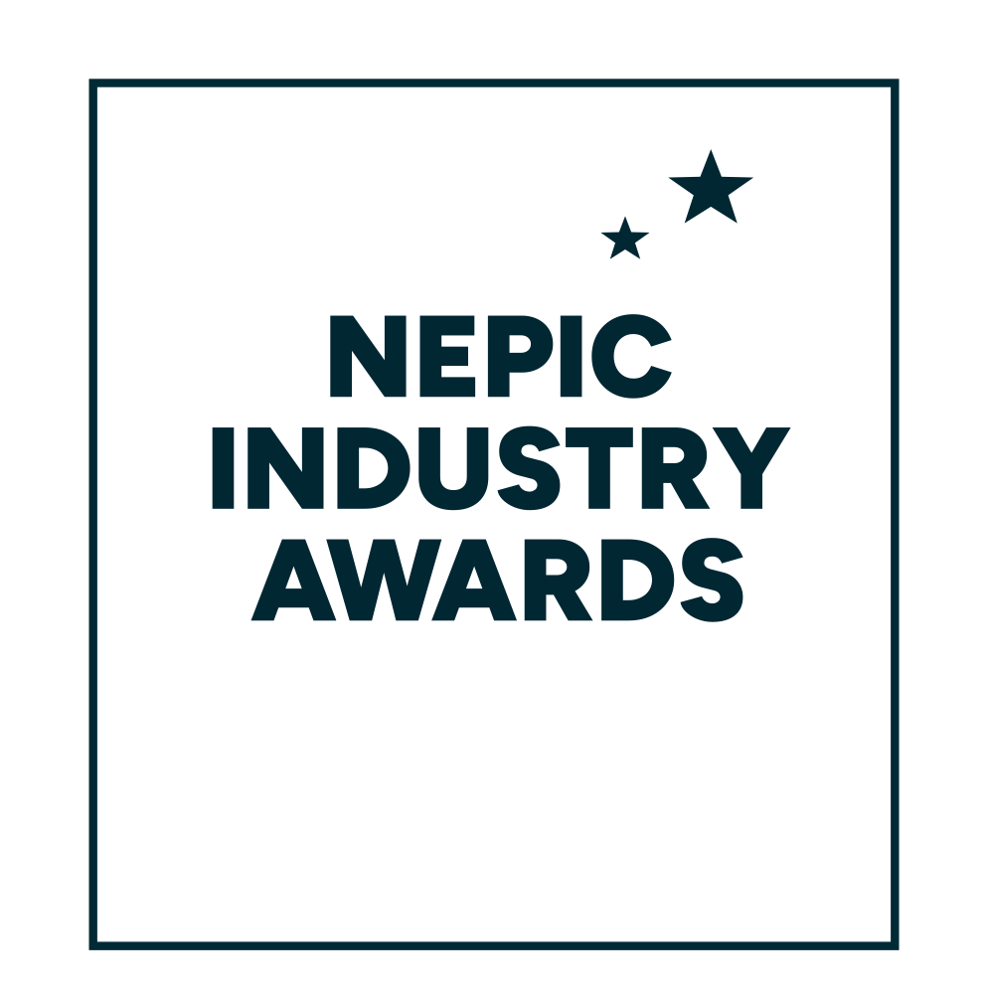

**28 March 2025**

**Hardwick Hall Hotel**

**ENVIRONMENTAL AWARD FOR NORTH EAST PRIMARY SCHOOLS**

Entry form and award criteria

#### ABOUT THE ENVIRONMENTAL AWARD FOR NORTH EAST PRIMARY SCHOOLS The objective of the School Environmental Award is to encourage environmental awareness & action of pupils by exploring & suggesting an environmentally themed project that could be delivered with the prize money from the award. How to enter in 3 easy steps! 1. A teacher suggests an environmentally themed project for a group of children, a whole class or the whole school (up to 11 years old). Typical projects might be, for example, a wildlife garden, a tree planting exercise, a field study that might require some materials or other costs, a recycling project, or bike racks to encourage parents and children to cycle to school – it’s up to you!

**2.** The teacher writes a short description of the project idea and a rough breakdown of how the £2000 prize fund would be spent. Key emphasis should be made on how the children will be involved in the project and how they and the environment would benefit. Please also get the children involved in the application process – we love to see drawings and written work from the children to detail how they imagine the project will turn out.

**3.** Submit the application to NEPIC – maximum of 400 words. Additional creative information in the form of photos, videos, children’s work may also be included. We also ask that the application is supported by a letter from the Head validating that funding will be ring fenced for this project.  
  
As well as receiving a trophy to mark the winner’s success at the prestigious NEPIC Annual Awards Dinner, held at Hardwick Hall on the evening of Friday 28 March 2025, the winning school will also receive £2,000 to develop their proposed project.

**How to enter:**  
  
Please complete the entry form below in full, ensuring you answer each of the 5 criteria.

Completed forms should be submitted electronically, clearly stating your name and chosen category on the top of the document, no later than the entry deadline of  
**Friday 17 January 2025** to [awards@nepic.co.uk](mailto:awards@nepic.co.uk).

**We wish you the very best of luck with your entry!**

**ENVIRONMENTAL AWARD FOR NORTH EAST PRIMARY SCHOOLS  
Entry form**

|  |
| --- |
|  |

|  |  |
| --- | --- |
| **School Details** |  |
| School Name |  |
| Contact Person |  |
| Job Title |  |
| School Address |  |
| Postcode |  |
| Telephone No. |  |
| Mobile No. |  |
| E-mail Address |  |
|  |  |

**ENVIRONMENTAL AWARD FOR NORTH EAST PRIMARY SCHOOLS  
Entry form**

**Part 2: Award Criteria**

**Please provide a supporting statement of 400 words max, as well as any other applicable information/drawings/classwork.**

|  |
| --- |
| 1. Please enter your statement here. Supporting documents can be submitted via email alongside this entry form. |
| Type statement… |