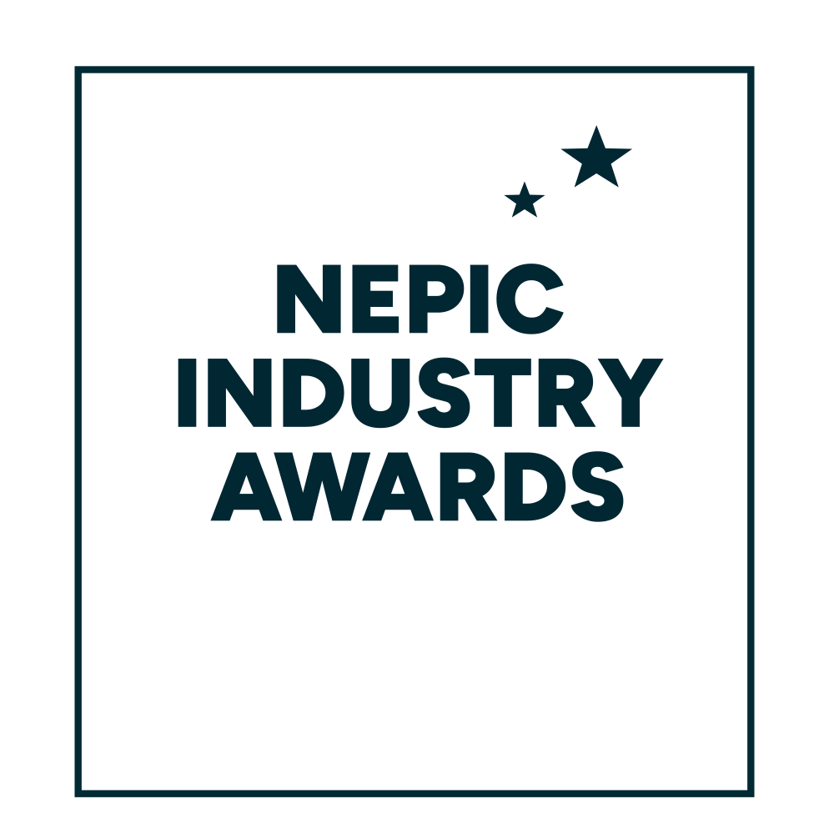

**28 March 2025**

**Hardwick Hall Hotel**

**INNOVATION AWARD**

Entry form and award criteria

**ABOUT THE INNOVATION AWARD**The Innovation Award seeks to recognize the standout member company of NEPIC that has actively pursued groundbreaking concepts, spanning products, processes, and services in the chemical processing industries and associated supply chain.

Judged on the innovation's uniqueness, the organisation's effective adoption, and its overarching impact on the company, industry, and environment, this award emphasises a demonstrable influence across various criteria.   
  
As well as receiving a trophy to mark the winner’s success at the prestigious NEPIC Annual Awards Dinner, held at Hardwick Hall on the evening of Friday 28 March 2025, the winning organisation will also receive £2,000* to donate to a local school of their choice to fund a science related project.  
  
**“I’M PROUD TO RECEIVE THE AWARD ON BEHALF OF SEQENS, THE WHOLE TEAM PRIDE THEMSELVES ON ABILITY, AGILITY AND ADAPTABILITY.”**Stephen Lark, from previous Innovation award winner, SEQENS

**How to enter:**  
  
Please complete the entry form below in full, ensuring you answer each of the 5 criteria.

Completed forms should be submitted electronically, clearly stating your name and chosen category on the top of the document, no later than the entry deadline of  
**31 December 2024** to [awards@nepic.co.uk](mailto:awards@nepic.co.uk).

**We wish you the very best of luck with your entry!**

**INNOVATION AWARD  
Entry form**

|  |
| --- |
|  |

|  |  |
| --- | --- |
| **Company Details** |  |
| Organisation |  |
| Contact Person |  |
| Job Title |  |
| Company Address |  |
| Postcode |  |
| Telephone No. |  |
| Mobile No. |  |
| E-mail Address |  |
|  |  |
| **\*Your Nominated School** |  |
| School Name |  |
| School Contact |  |
| Address |  |
| Postcode |  |
| Telephone No. |  |
| E-mail Address |  |

**INNOVATION AWARD  
Entry form**

**Part 2: Award Criteria**

**Please provide a supporting statement for each of the 5 criteria.**

|  |
| --- |
| 1. Please give the **title of the innovation** and the key drivers for its development and adoption.  *You could include how you identified the need, the technological advancements, market demands, environmental considerations, strategic alignment, and the competitive edge.* |
| Type answer… |

|  |
| --- |
| 1. Give a brief description of the innovation. |
| Type answer… |

|  |
| --- |
| 1. What are the key features that make the innovation unique? *List the main features and functionalities that make it unique.* |
| Type answer… |

|  |
| --- |
| 1. Please explain any environmentally-friendly aspects or sustainability considerations of your innovation. |
| Type answer… |

|  |
| --- |
| 1. Describe how your innovation could address challenges and bring positive changes to the process industry and associated supply chains. Please also outline the future for this innovation. |
| Type answer… |