NEPIC MEET THE MEMBERS 2024
Exhibitor Booking Form

Thank you for booking your exhibition space at the 2024 NEPIC Meet the Members Conference & Expo.
Please complete the following form and return to victoria.pepper@nepic.co.uk. This will ensure we have all of your requirements and can provide you with the best exhibition experience at this year’s event.
Stand Type  (Please tick the relevant box) | ☐ Standard flat frame  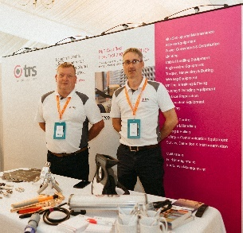 | ☐ Rounded stand  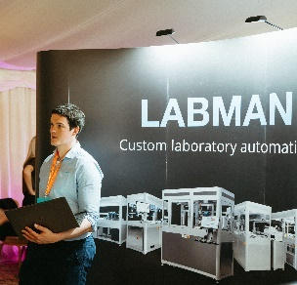 | ☐ Pop up banner(s)  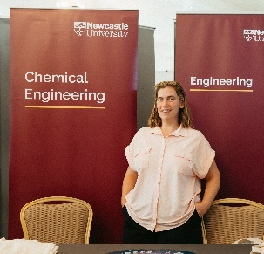 | ☐ Other  (please specify):  Click or tap here to enter text.
Power Supply | I require a power supply. | ☐ Yes  ☐ No | If yes please state if you need anything additional:  Click or tap here to enter text.
Table/ Chairs | I require a table, 2 chairs & linen | ☐ Yes  ☐ No
Extras | I am bringing extra equipment (e.g. Plinth, TV, machinery) | ☐ Yes  ☐ No | If yes please state what you are bringing here:  Click or tap here to enter text.
Please state the exact dimensions of stand plus any additional equipment you plan to bring with you. |  | Click or tap here to enter text.
☐ By checking this box I confirm that my exhibition stand and any additional equipment will fit within the designated area (3m x 1m).*
ALL EQUIPMENT MUST BE REMOVED ON THE DAY OF THE EVENT AND ANY DELIVERIES NEED TO BE BOOKED IN ADVANCE. ☐ By checking this box I confirm that I agree to these terms.
* Please note: Your booking is for a set space of 3m x 1m. If your stand or any additional equipment will exceed this please specify in the relevant field above. There will be an extra charge for anything that is in excess of the allocated area and NEPIC will select your stand location accordingly.

